Emergency Info

Student’s full name(s):
Date of birth:

Any allergies, medications or special conditions:

Home address:

Closest major intersection:

Police Department (non emergency) (250) 248-6111
Poison Control:
1-800-567-8911

Fire Department: (non emergency) (250) 248-3242 Parksville
(250) 752-6232 Qualicum
Other Emergency #:

Family Doctor:
Family Doctor phone:

Address: Directions:

Dentist:
Dentist phone:

Preferred hospital:
Hospital phone:

Address: Directions:

Insurance provider:
Insurance provider phone:

Insured name and ID:

Group ID:

Policy ID:

Host Mom’s full name:
Preferred phone: Other phone:
Host Dad’s full name:
Preferred phone: Other phone:

Emergency contact 1:
Phone: Relation:
Emergency contact 2:
Phone: Relation:

Neighbor(s):

Phone:

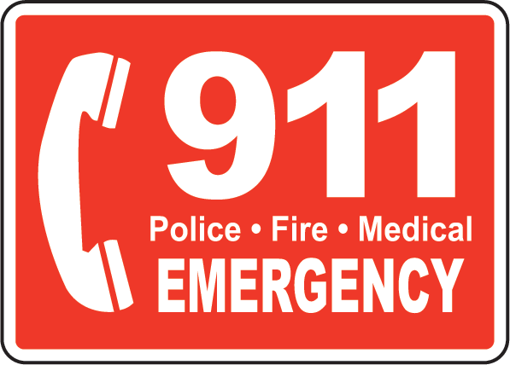

Address:

